Local Environment Setup

This document contains information on setting up your local macOS and Windows environment for developing Backend projects using Java, Springboot, Gradle, and MongoDB/MySQL.

# Setup for macOS

## Minimum Requirements

Please ensure the following requirements are satisfied before getting started.

Operating System: Mac OS X 10.13 (High Sierra) or later

Hardware: Mac with at least 4GB of RAM and a multi-core processor

## Homebrew Installation

Homebrew is a free and open-source software package management system that simplifies the installation of software on Apple's operating system, macOS, and Linux. Homebrew is required to streamline the setup process.

To install Homebrew, please watch this video: [How to Install Homebrew on Mac](https://www.youtube.com/watch?v=IWJKRmFLn-g)

### Verify Installation

Before going ahead, ensure that Homebrew is correctly installed. Type brew --version in the command line to verify the installation. Ensure that it returns the homebrew version as seen in the screenshot below.

## Java Installation

Java 17 or later is required to build projects using the latest Spring version, Spring 3.

To install the latest stable version of Java, Java 21, type the following command in the terminal:

brew install openjdk@21

After the installation is completed, type the following command in the terminal:

sudo ln -sfn $HOMEBREW_PREFIX/opt/openjdk/libexec/openjdk.jdk /Library/Java/JavaVirtualMachines/openjdk.jdk

This is done to ensure that the system can locate the newly installed JDK resources.

### Verify Installation

To verify the installation, **restart the terminal** and type the following command:

java --version

Ensure that it returns the Java version (OpenJDK 21) as seen in the screenshot below.

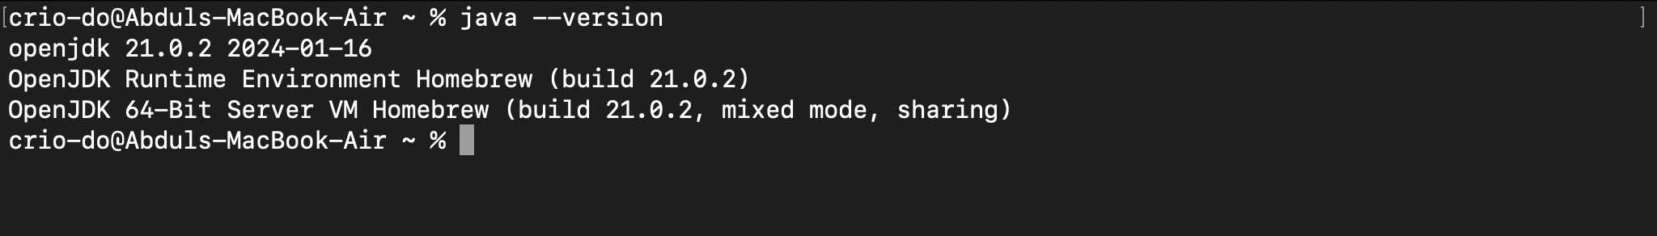

## Gradle Installation

Gradle is a build automation tool for multi-language software development. It controls the development process in the tasks of compilation and packaging to testing, deployment, and publishing.

To install Gradle, type the following command in the terminal:

brew install gradle

### Verify Installation

To verify the installation, type the following command in the terminal:

gradle -v

Ensure that it returns the gradle version as seen in the screenshot below.

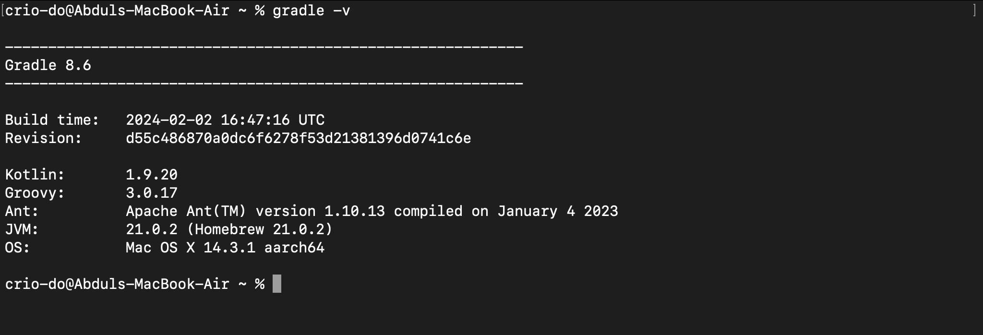

## Visual Studio Code Installation

Visual Studio Code, commonly called VS Code, is a source-code editor developed by Microsoft for Windows, Linux, and macOS.

To install VS Code, type the following command in the terminal:

brew install --cask visual-studio-code

### Verify Installation

Ensure that the brew install returns a success message as seen in the screenshot below.

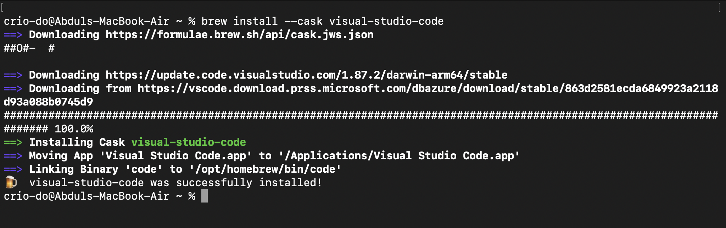

After successful installation, type code . in the command line or manually search for VS Code from Spotlight to launch the application.

### Configuring VS Code Extensions for Java

VS Code extensions let you add languages, debuggers, and tools to your installation to support your development workflow. To streamline Java development, ensure that the following extensions are installed. All the required extensions can be installed by installing the “[Extension Pack for Java](https://marketplace.visualstudio.com/items?itemName=vscjava.vscode-java-pack)”.

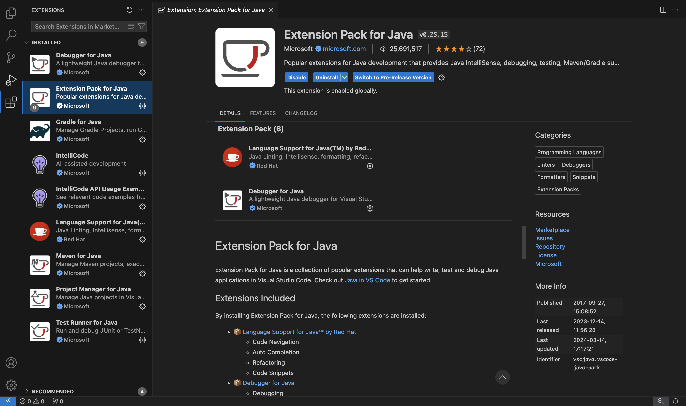

## MongoDB Installation

Follow these steps to install MongoDB Community Edition using Homebrew's brew package manager.

1. Tap the MongoDB Homebrew Tap to download the official Homebrew formula for MongoDB and the Database Tools, by running the following command in your macOS Terminal:   
   brew tap mongodb/brew
2. To update Homebrew and all existing formulae:  
   brew update
3. To install MongoDB, run the following command in your macOS Terminal application:  
   brew install mongodb-community@7.0

### Verify Installation

To verify the installation, type the following command in the terminal:

mongod --version

Ensure that it returns the db version as seen in the screenshot below.

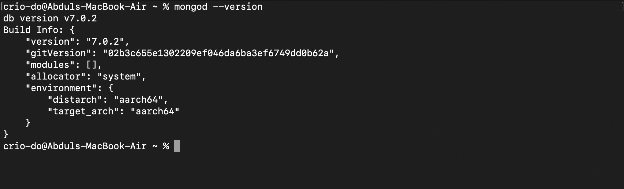

If you run into issues while setting up MongoDB, please refer to this documentation:

[Install MongoDB Community Edition on macOS](https://www.mongodb.com/docs/manual/tutorial/install-mongodb-on-os-x/)

### Start and Use MongoDB Community Edition

To start MongoDB (i.e. the mongod process) as a macOS service, type the following command in the terminal:

brew services start mongodb-community@7.0

To begin using MongoDB, connect mongosh to the running instance. From a new terminal, type the following command:

mongosh

### Stop MongoDB Community Edition

To stop MongoDB (i.e. the mongod process) as a macOS service, type the following command in the terminal:

brew services stop mongodb-community@7.0

## MySQL Installation

To install Gradle, type the following command in the terminal:

brew install mysql

### Verify Installation

To verify the installation, type the following command in the terminal:

mysql --version

Ensure that it returns the MySQL version as seen in the screenshot below.

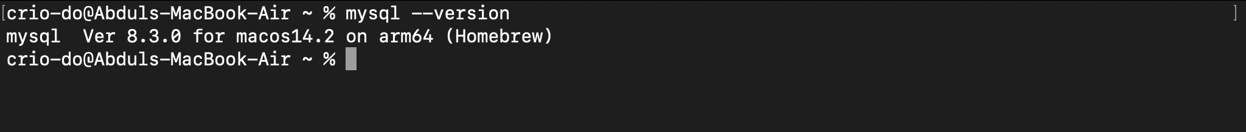

If you run into issues while setting up MySQL, please refer to this documentation:

[Installing MySQL on macOS](https://dev.mysql.com/doc/mysql-installation-excerpt/8.3/en/macos-installation.html)

### Start and Use MySQL

To start MySQL type the following command in the terminal:

brew services start mysql

To begin using MySQL, from a new terminal, type the following command:

mysql -u root -p  
the

### Stop MySQL

To start MySQL type the following command in the terminal:

brew services stop mysql

### MySQL Workbench

MySQL Workbench is a visual tool to design, develop, and administer MySQL servers.

To install MySQL type the following command in the terminal:

brew install --cask mysqlworkbench

### Verify Installation

Ensure that the brew install returns a success message as seen in the screenshot below.

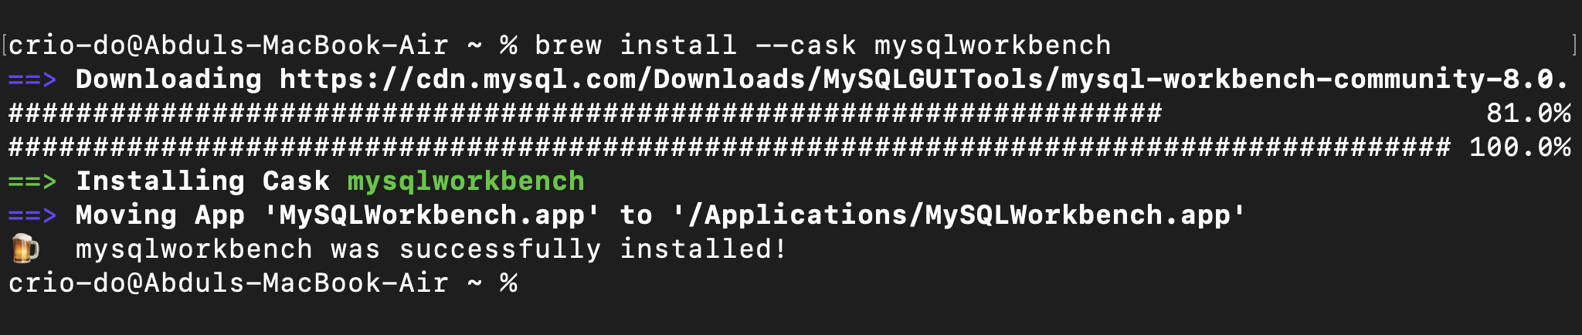

After successful installation, manually search for MySQLWorkbench Code from Spotlight to launch the application.

After launching the application, ensure that your window looks similar to the screenshot below.

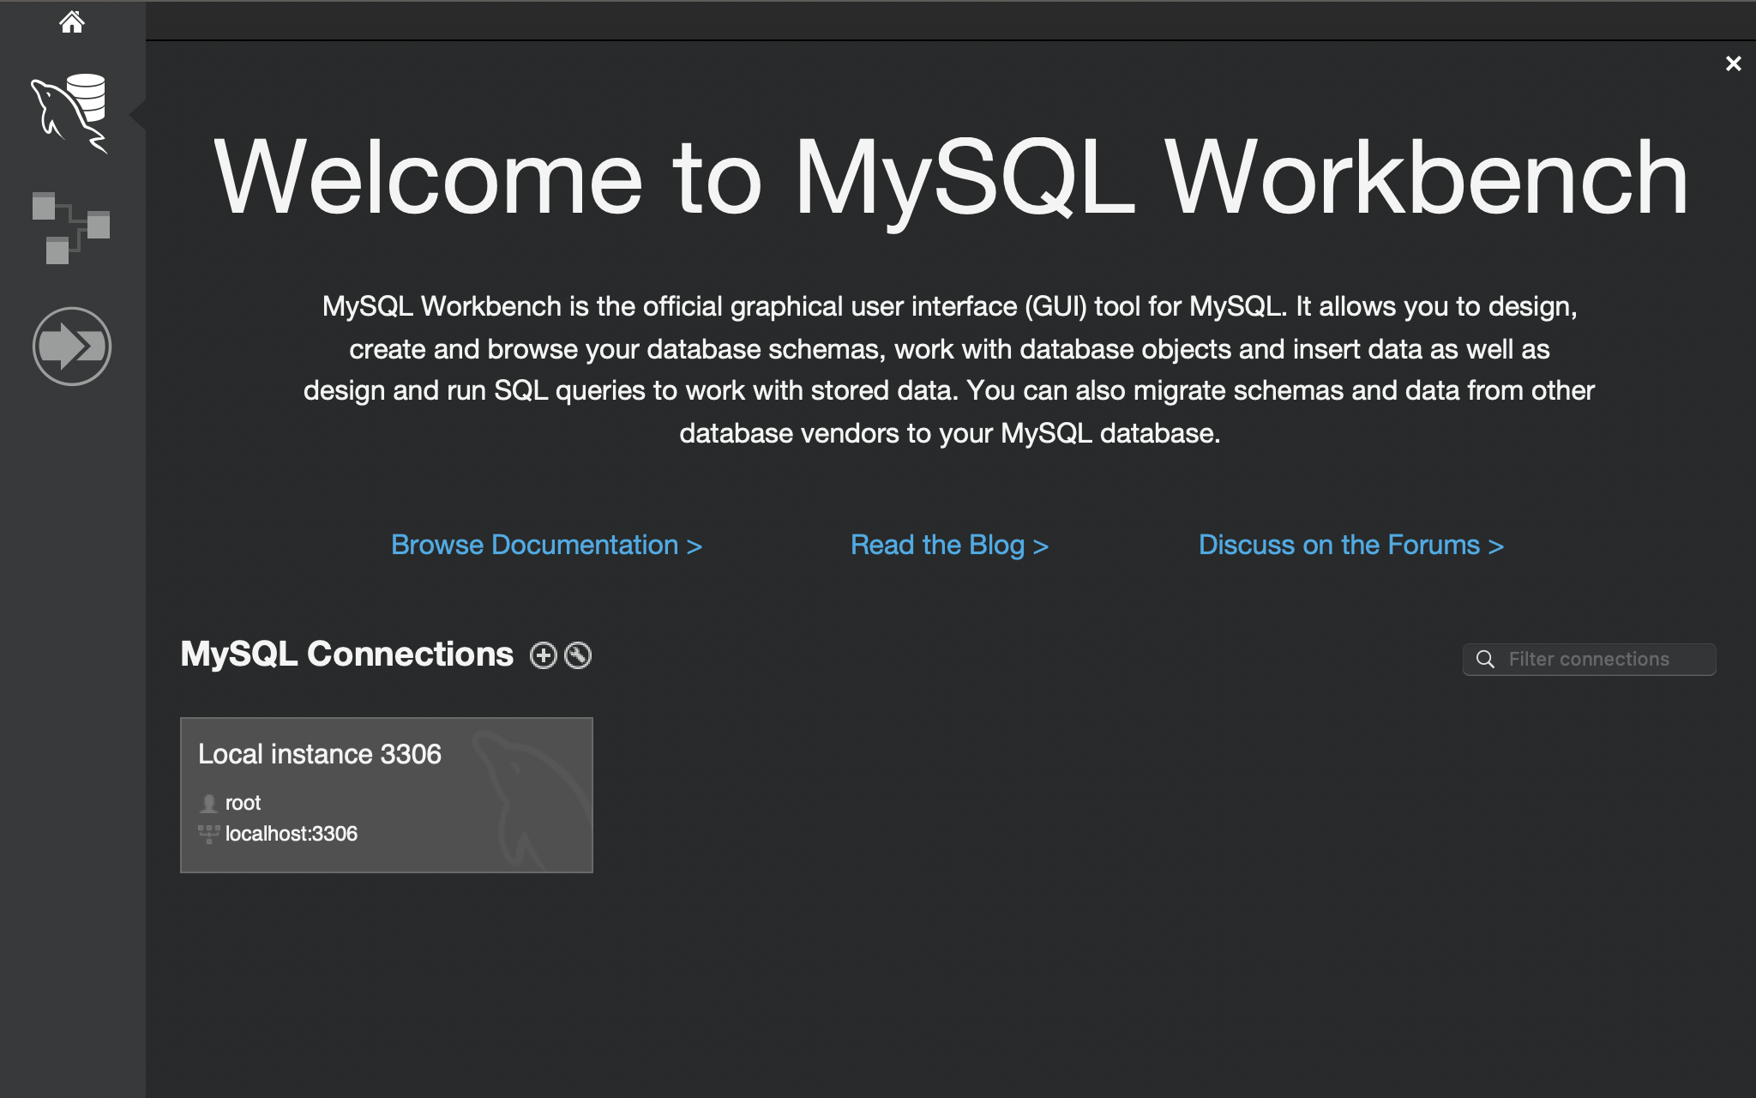

# Setup for Windows

## Minimum requirements

Please ensure the system meets the following requirements:

* Windows : 7 and above
* RAM : 4GB minimum
* Processor : I3 minimum

## Java Setup for windows

* **Step:1**

Download the latest version of java installer compatible for windows from link given below

<https://www.oracle.com/in/java/technologies/downloads/#jdk21-windows>

* **Step:2**

Run the Executable file

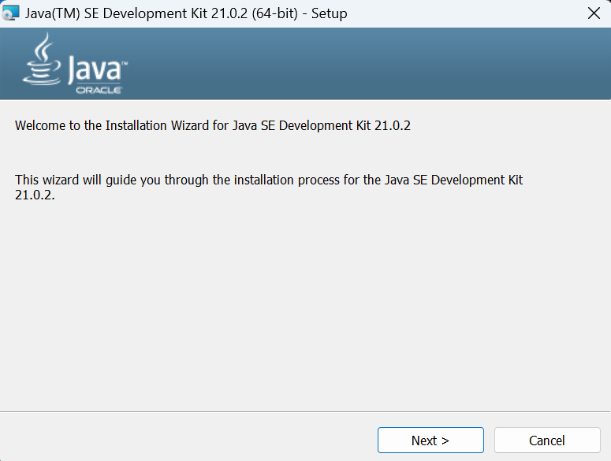

Click on Next

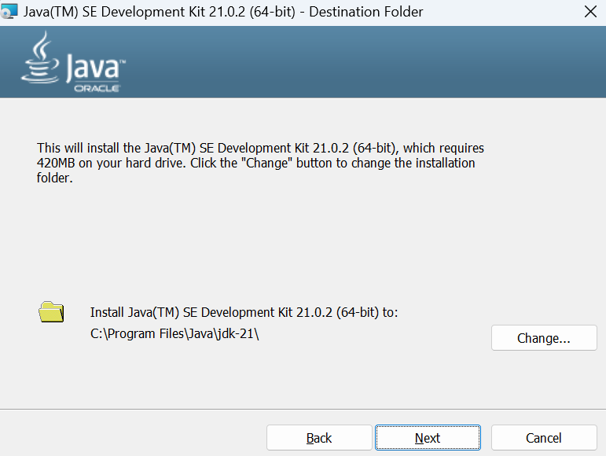

Click on Next

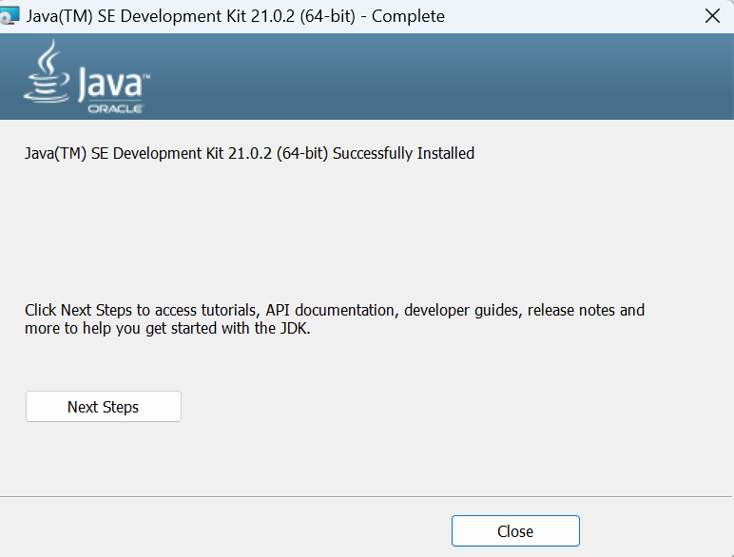

With this Java Will be installed in the system.

* **Step:3** - Environment Setup
  + Got To **This PC**
  + Right click on **This PC**
  + Go to **Advanced System Settings**

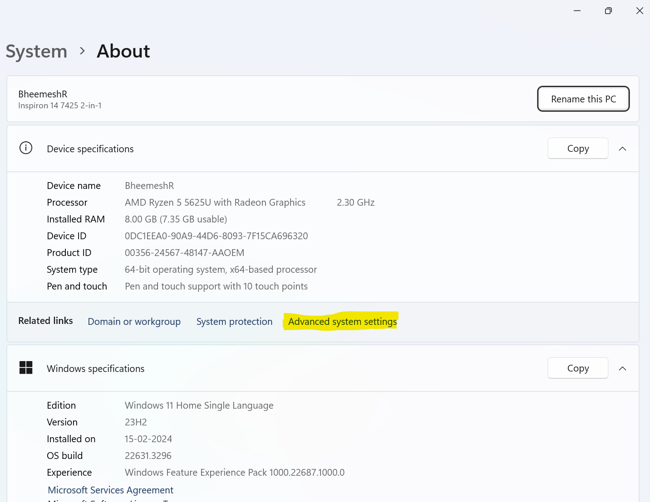

* + Go to **Environment Variables**

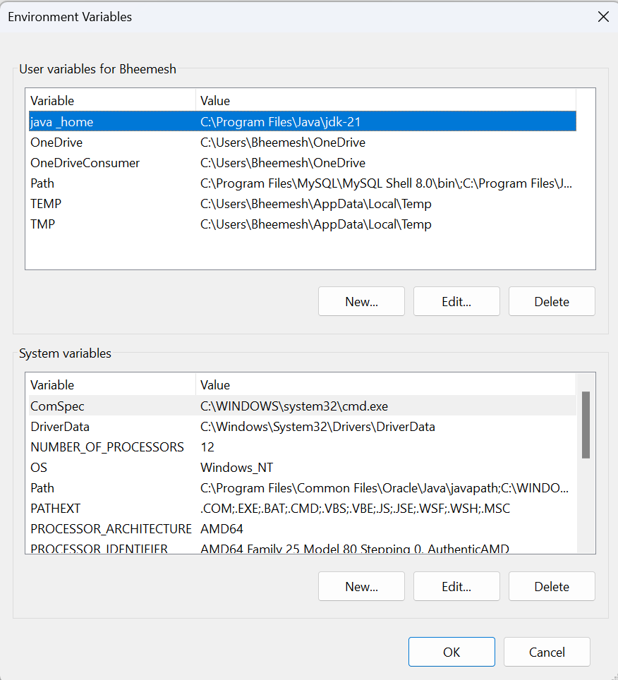

* + Click on **new button under system variables**
  + Enter the Variable Name as : **Java_Home**
  + Enter the variable Path as : **C:\Program Files\java\jdk-21**

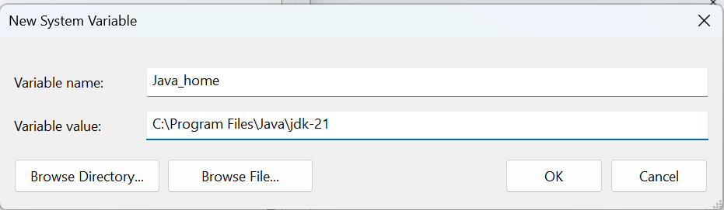

* + Click on **OK**
  + Click on **Apply**
* Step:4
  + Open Command Prompt and type as **java --version**

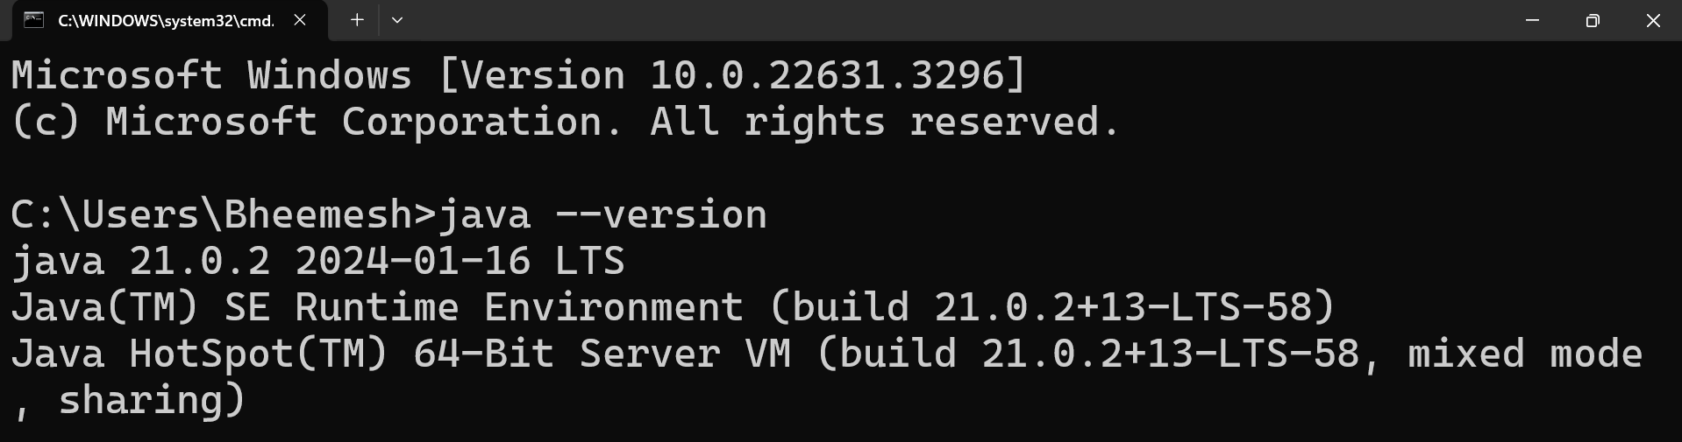

**This confirms the installation of java in the system**

## VS Code Setup for windows

* Visit <https://code.visualstudio.com/download> and download the version specific to your OS.

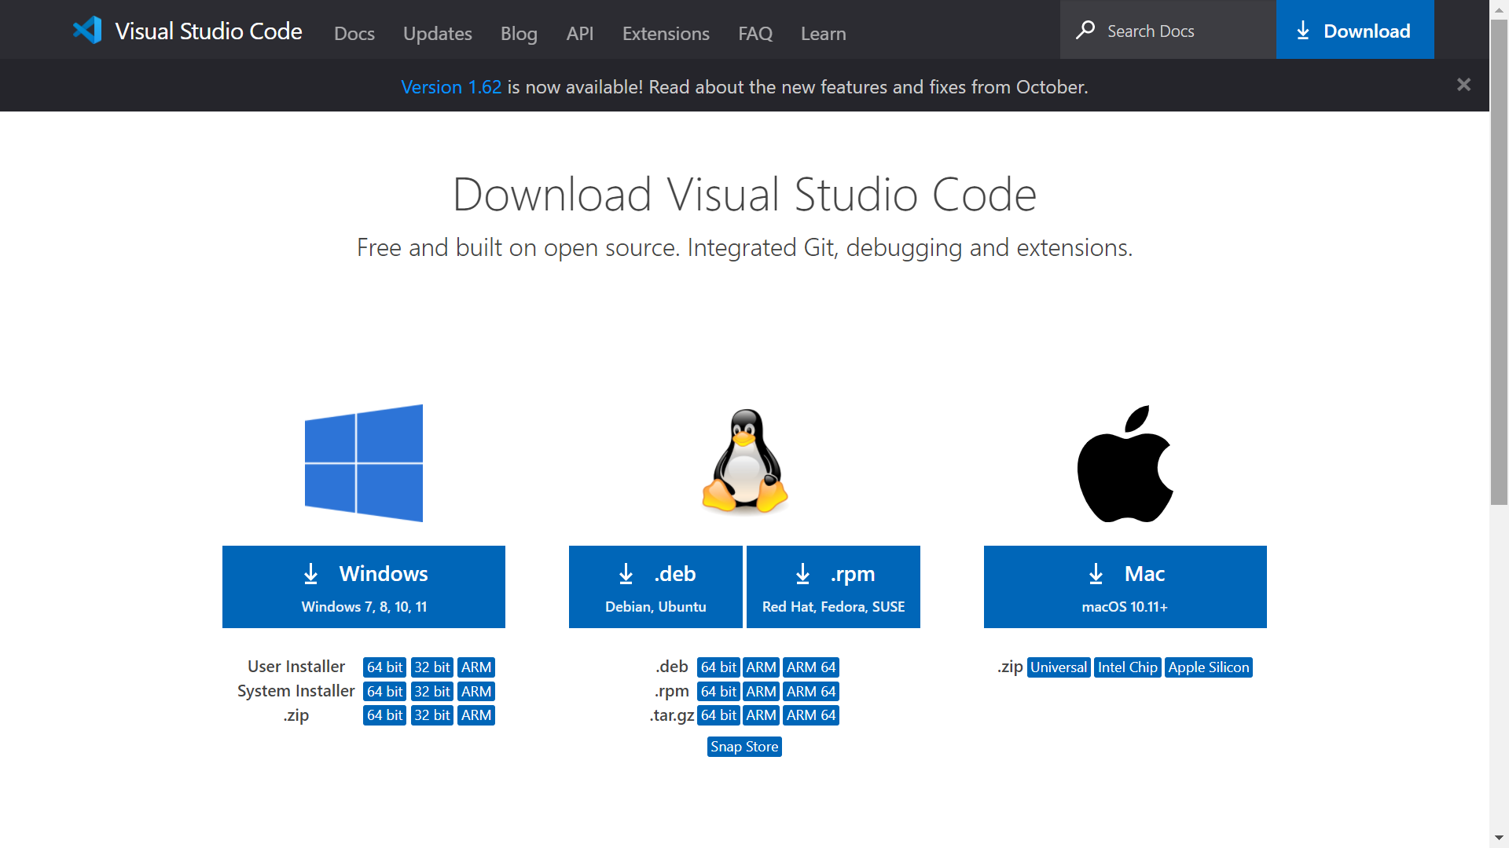

* Once the download is complete. Open the file and accept the agreement.

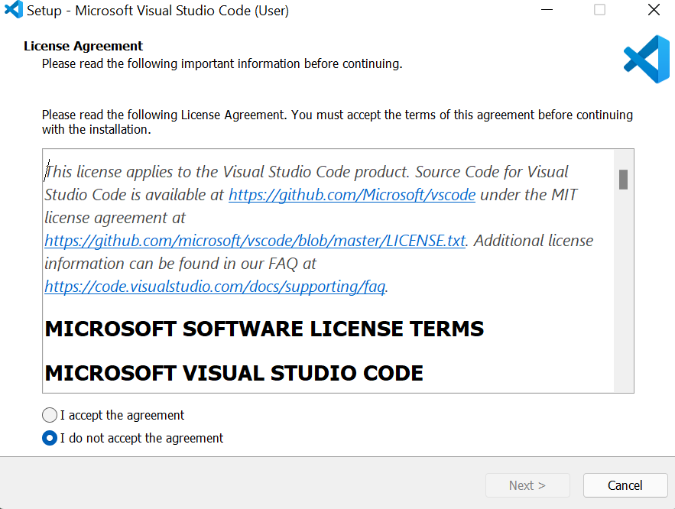

* Select the drive location where you need to install the VS Code.

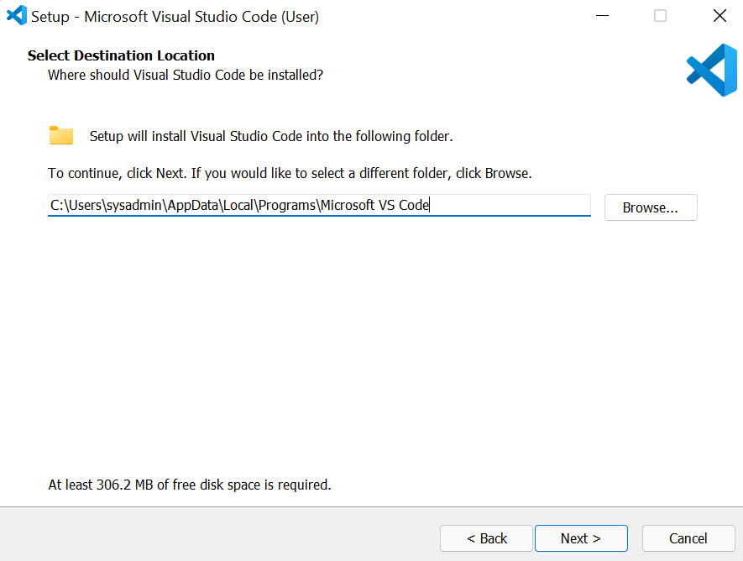

* Select the folder name for the VS Code setup files.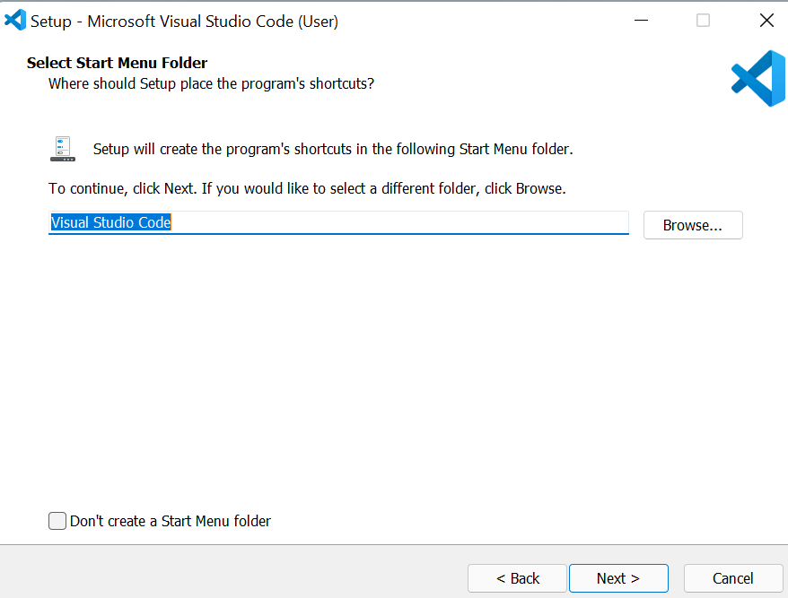
* Select the additional task, you want to do by the installer. I wanted to have "Open with Code" added to both the File and Directory content menu, hence I selected those.

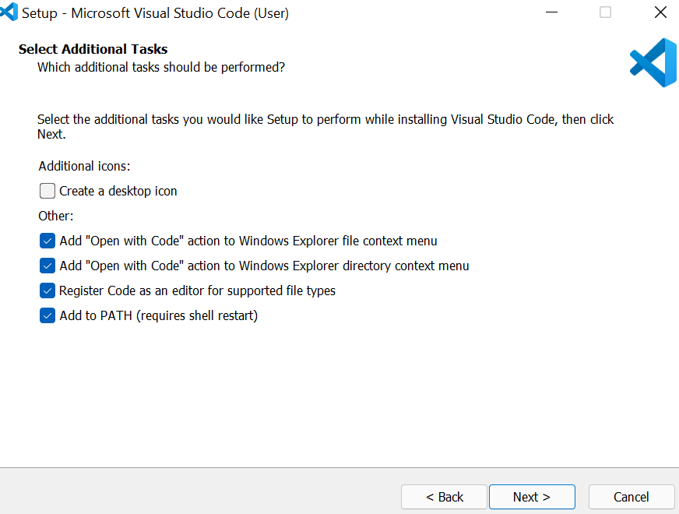

* Check if all the settings. Click on "< Back" if you need to change anything.

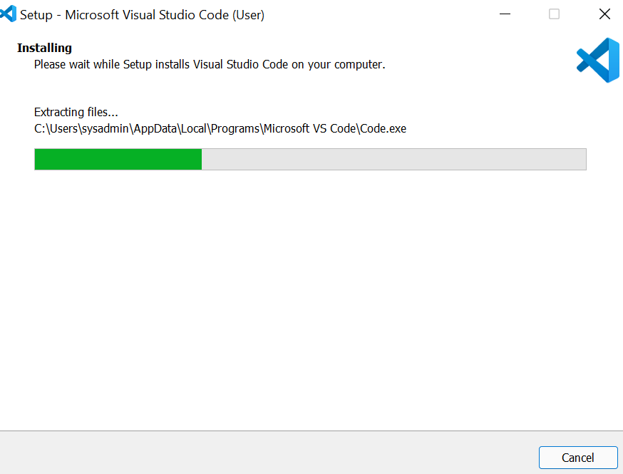

* After installation, click "Finish"

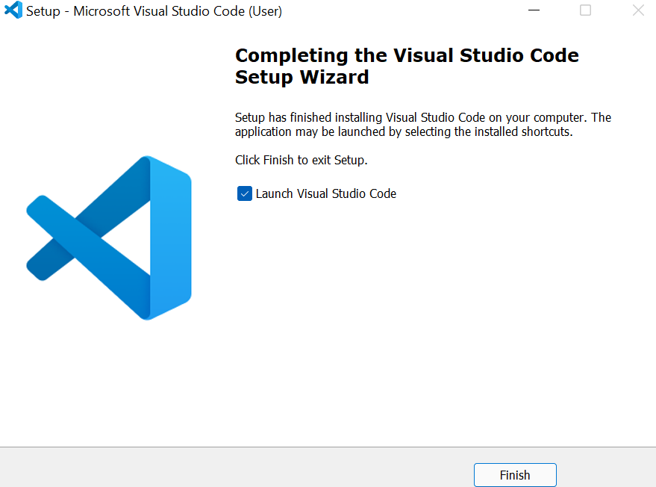

# 

## MongoDB Setup for Windows

### Step 1 — Download the MongoDB MSI Installer Package

Head over [here](https://www.mongodb.com/download-center/community) and download the current version of MongoDB. Make sure you **select MSI** as the package you want to download.

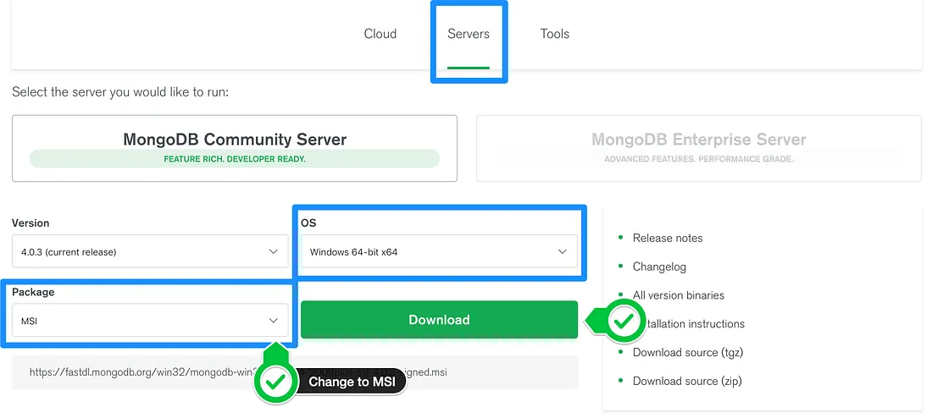

### Step 2 — Install MongoDB with the Installation Wizard

A. Make sure you are logged in as a user with Admin privileges. Then navigate to your downloads folder and double click on the .msi package you just downloaded. This will launch the installation wizard.

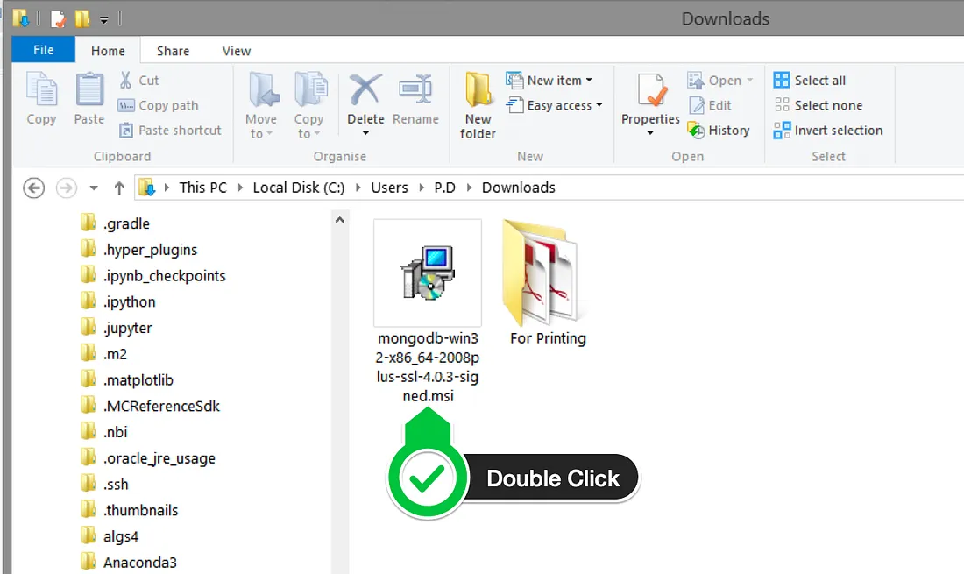

Click Next to start installation.

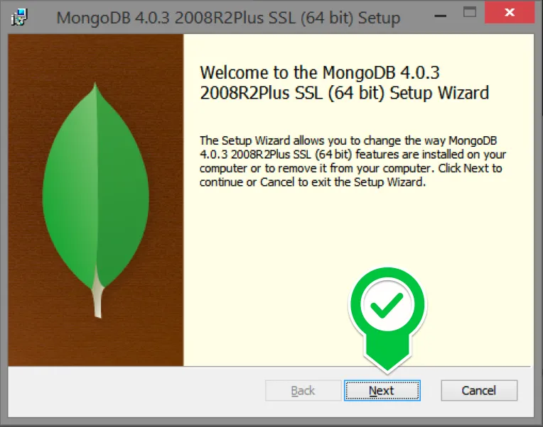

Accept the licence agreement then click Next.

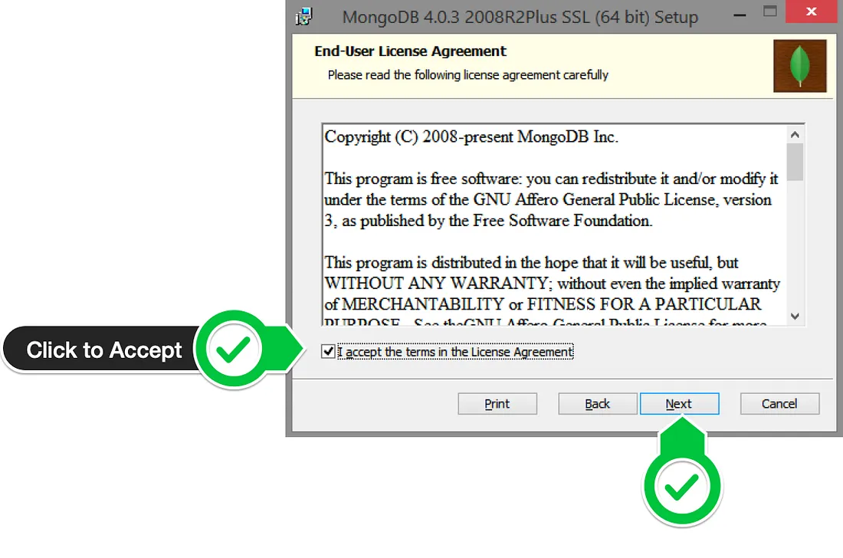

Select the Complete setup.

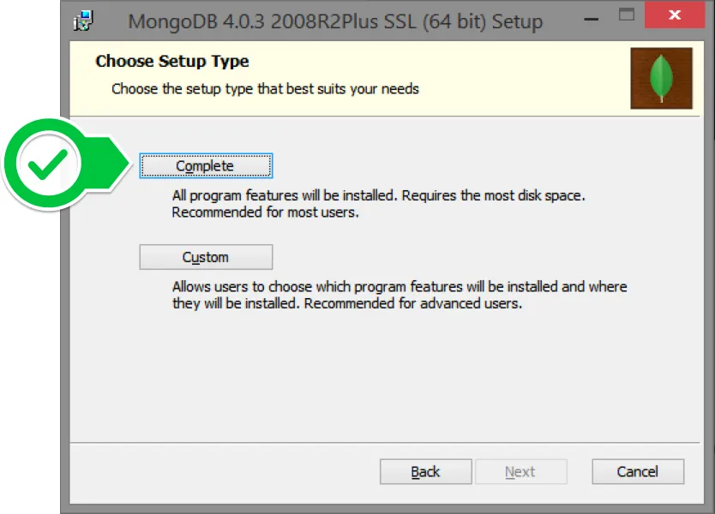

Select “Run service as Network Service user” and make a note of the data directory, we’ll need this later.

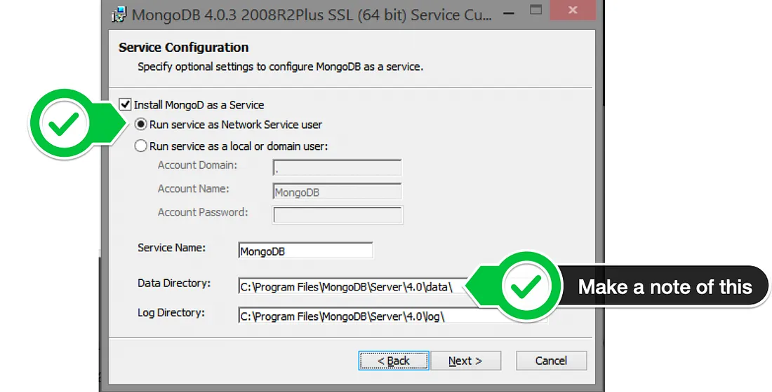

Click Install to begin installation.

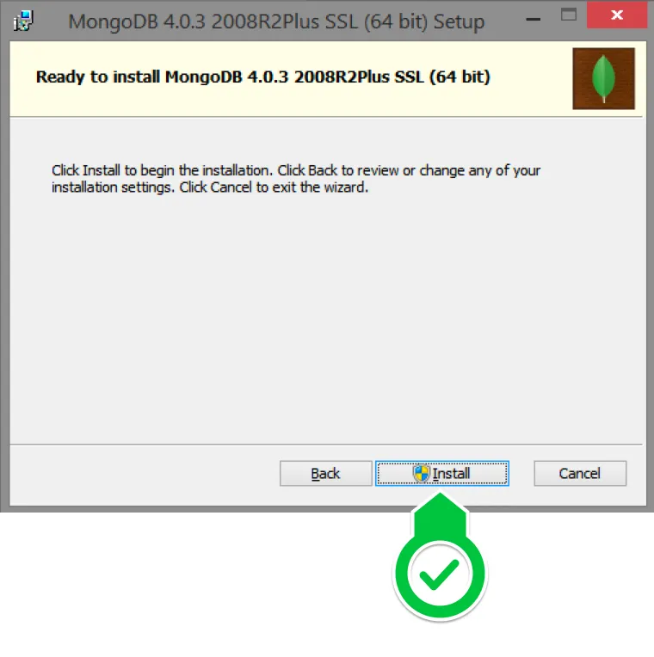

## MySQL Setup for windows

* Open the MySQL website on a browser. Click on the following link:  
  <https://www.mysql.com/downloads/>
* Select the Downloads option.

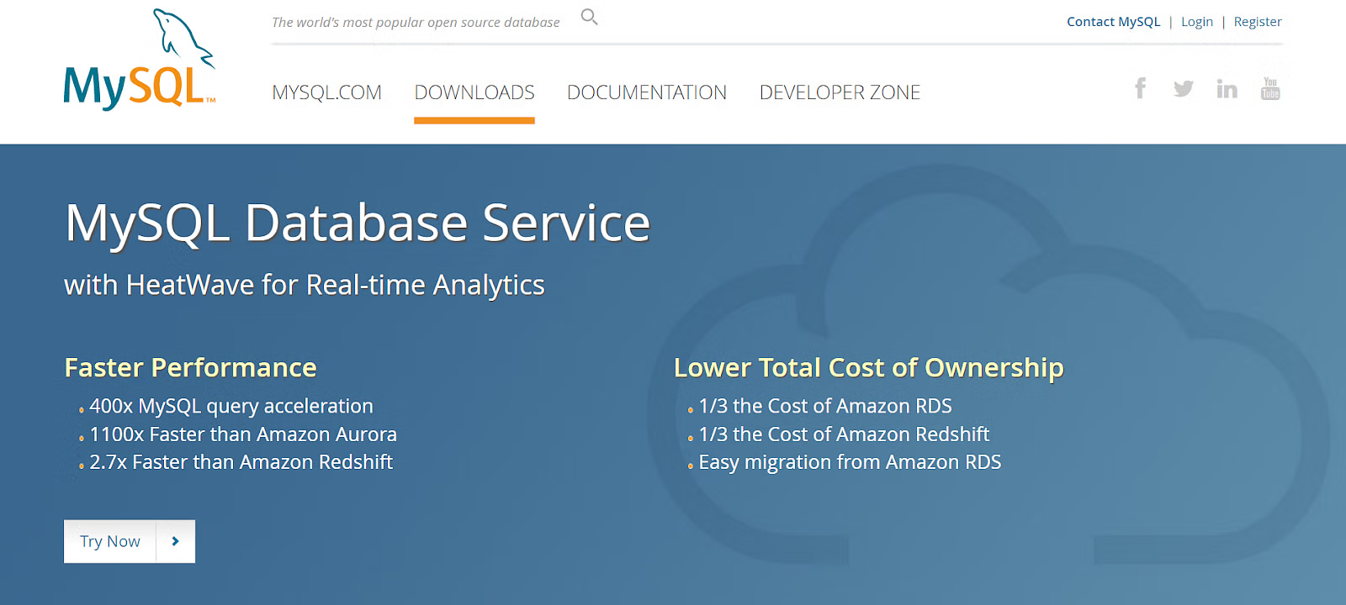

* Select MySQL Installer for Windows.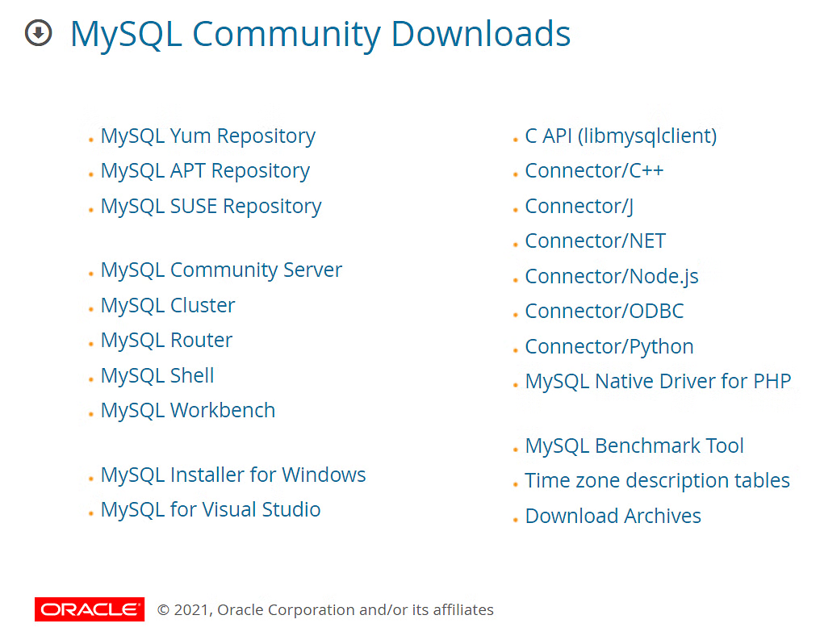
* Choose the desired installer and click on download.

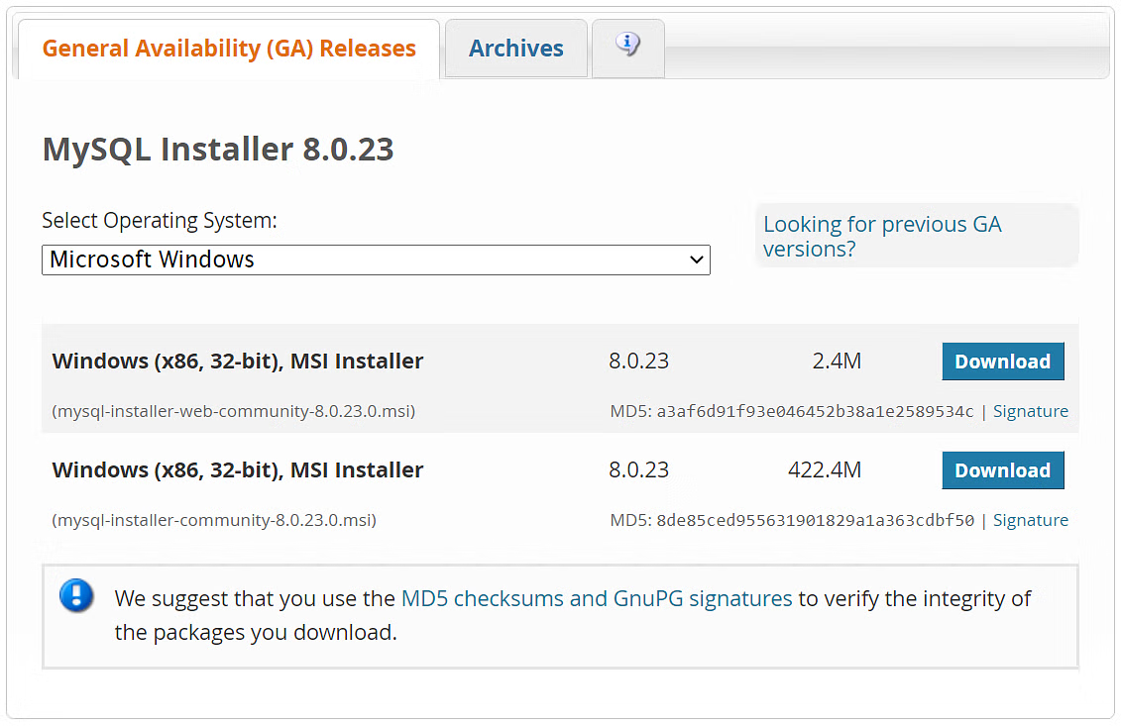

* After the download, open the installer.

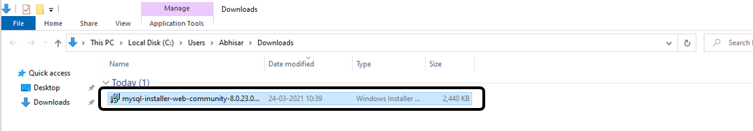

* It will ask for permission; when it does, click Yes. The installer will then open. Now, it will ask to choose the setup type. Here, select Custom.

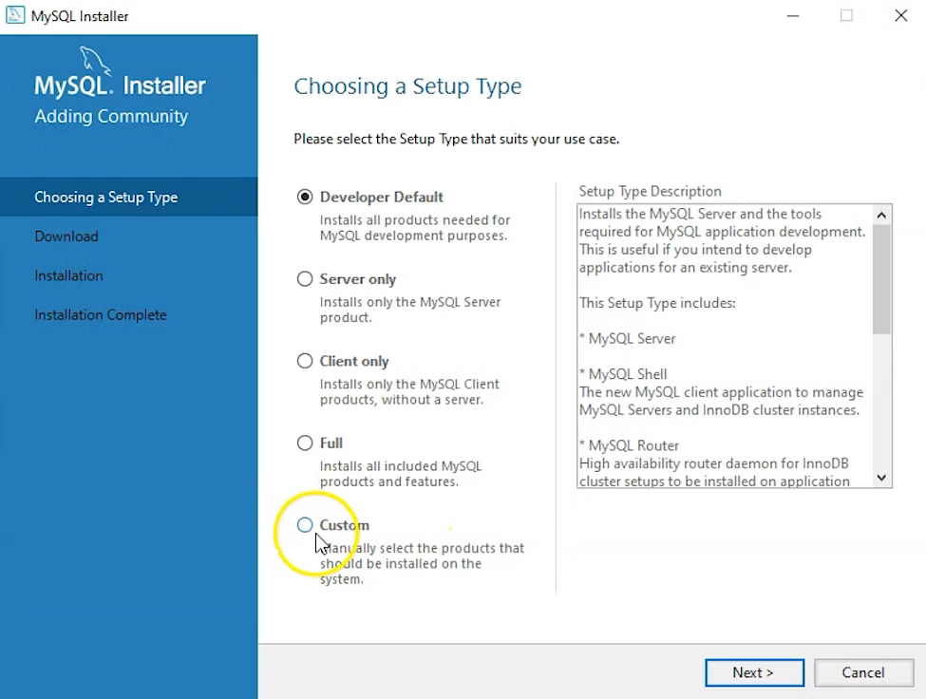

* Click on Next. With this, you will install MySQL server, MySQL Workbench, and MySQL shell.
* Open MySQL Servers, select the server you want to install, and move it to the Products/Features to be installed window section. Now, expand Applications, choose MySQL Workbench and MySQL shell. Move both of them to ‘Products/Features to be installed’.

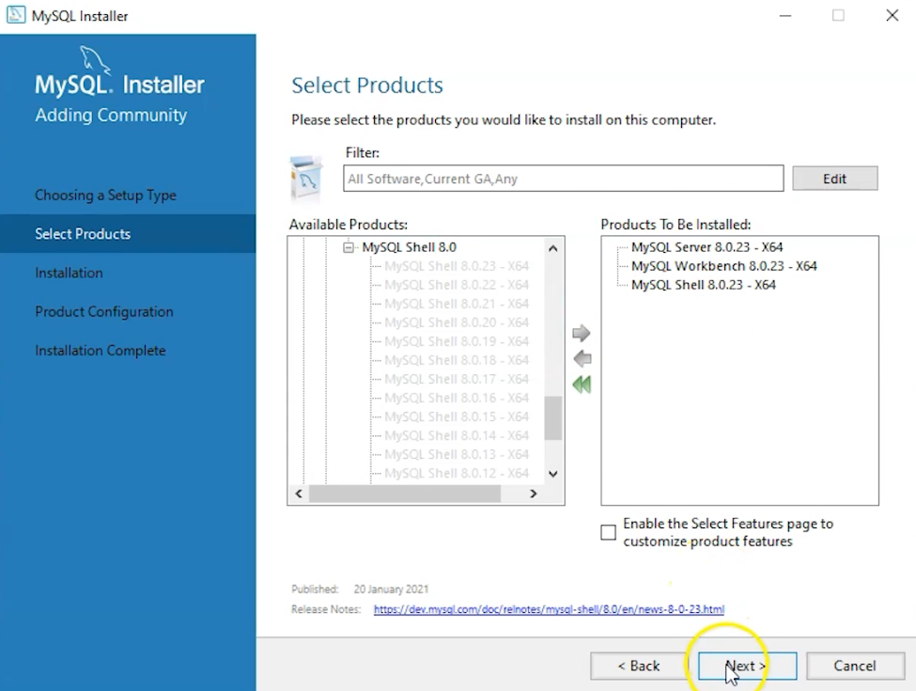

* Click on the Next button. Now, click on the Execute button to download and install the MySQL server, MySQL Workbench, and the MySQL shell.

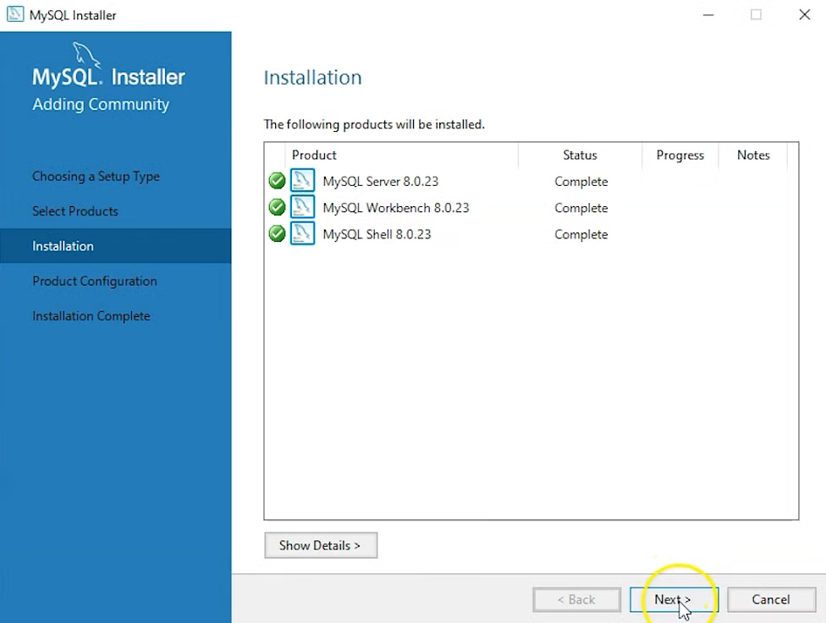

* Once the product is ready to configure, click on Next. Under Type and Networking, go with the default settings and select Next.

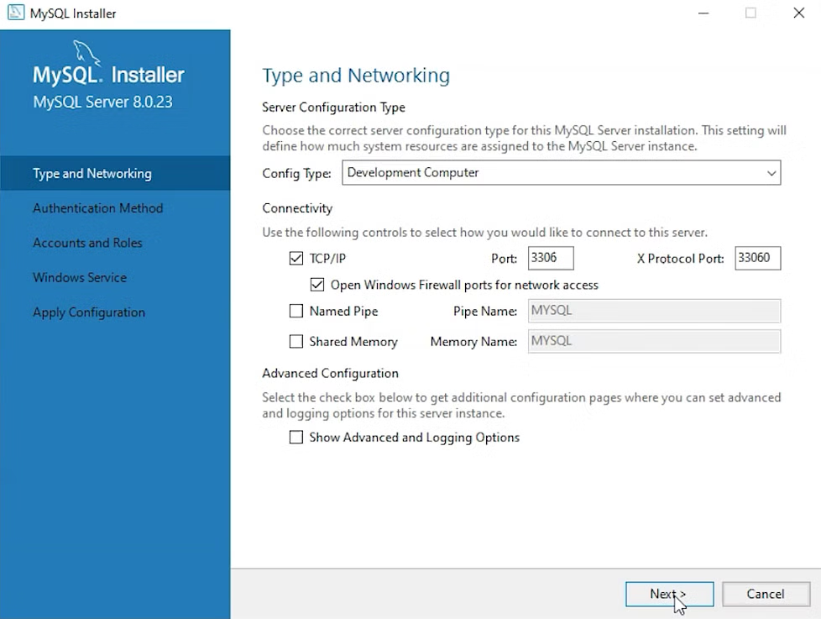

* For authentication, use the recommended strong password encryption.
* Set your MySQL Root password and click on next.

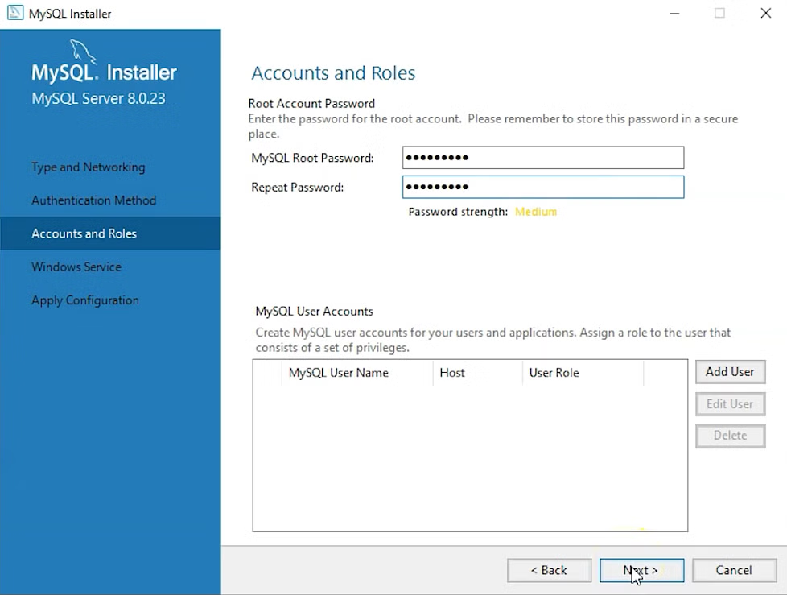

* Go for the default windows service settings and under apply configuration, click on execute. Once the configuration is complete, click on finish.

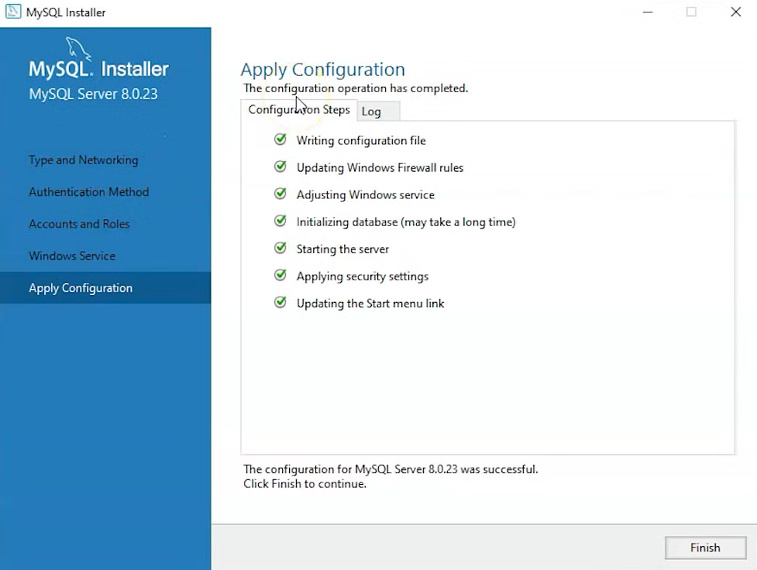

* Complete the installation. This will now launch the MySQL Workbench and the MySQL Shell.

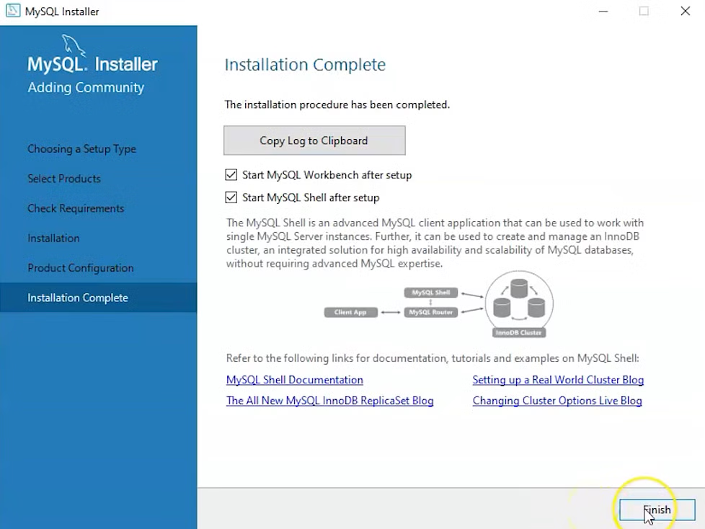

* Once MySQL Workbench is installed, select the Local instance and enter the password.

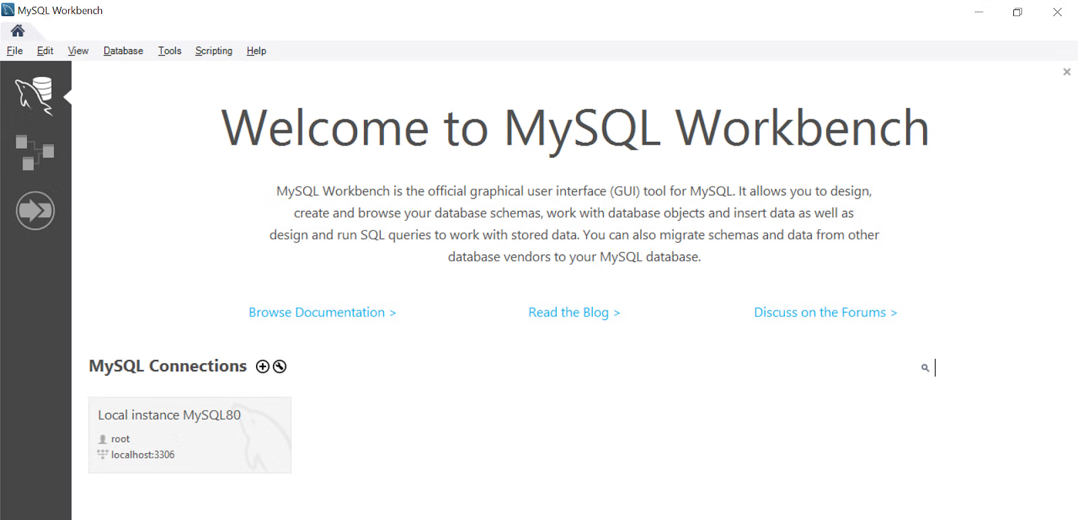

## Gradle Setup for windows

* Check if Java is installed in your local system.
  + Open command prompt and type: **java --version**
* Download Gradle
  + To download the latest version, type Download Gradle on your browser and open the first link. Or you can go to the following link [<https://gradle.org/install/>]
  + Next, download the latest version of Gradle distribution.
  + Now, click on “Download” on the website.

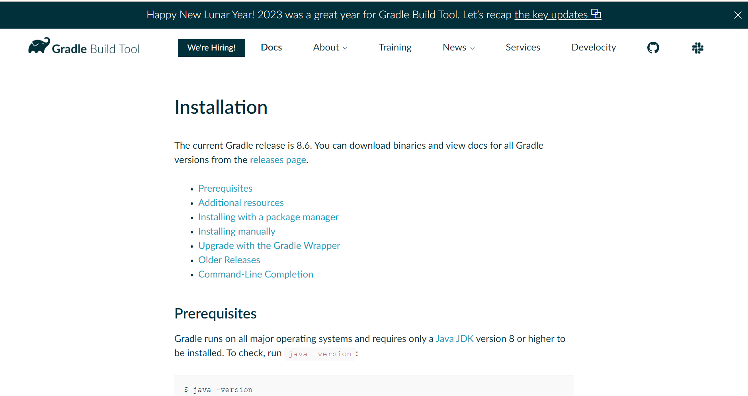

The distribution ZIP comes in two files:

1. Binary-only (bin)
2. Complete (all) with docs and sources

We will take the “Binary-only (bin)” and browse for docs and sources online.

* Select the latest version of Gradle and download “binary-only”.
* Now, wait for the downloading to finish.

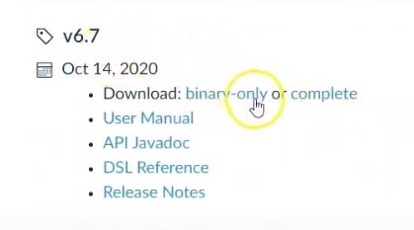

* Now go to ‘downloads’ and extract the files.   
  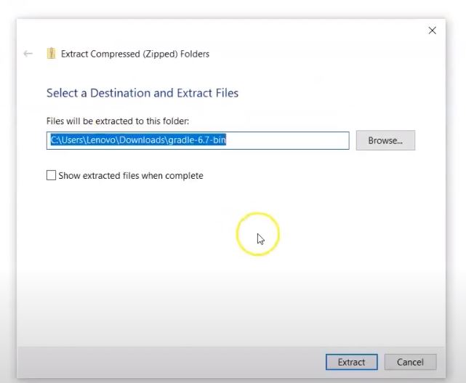
* Setting up the environment refers to extracting the distribution file and copying the library files into the desired location.
* Open the folder that appears on the screen.
* Go inside the bin folder and copy the path.
* Now, go to this
* PC or My Computer -> right click on the This PC icon -> select the properties option -> go for Advanced system settings -> click on Environment Variables
* When the dialog box appears, do the following: In the   
  Variable name: “Gradle_Home”  
  Variable value: paste the bin address copied before (removing “bin” from the address).
* Click on “OK”.
* Then click on Path in the list.
* In the dialog box that appears, make a new entry.
* Paste the bin directory address copied above.
* Click on OK.
* Now, after the complete extraction is done, you can go forward to verify if the Gradle installation is finished or not.
* Now open the command prompt.
* In the command prompt, enter **Gradle -version.**
* It will display the current version of Gradle just installed on the screen.